INTERNSHIP REPORT

Title: Single page website

**Internship Details:**

Name of the Intern: Pawan B

Internship Duration: 8 weeks (may- July)

Internship Position: Web development front end.

**Academic Institution Details:**

Name of the Institution: JSS Academy of Technical Education, Bangalore Department/Program: CSE(AIML).

 

Date of Submission: 06-Aug-2023

**Abstract**

The advent of the internet has revolutionized the way we access information, interact with businesses, and connect with others. Websites, in particular, have become an integral part of our digital landscape. Over the years, web design trends have evolved, and one approach that has gained significant popularity is the single-page website.

This paper aims to explore the phenomenon of single-page websites and delve into the reasons behind their widespread adoption. We will analyse the characteristics, advantages, and challenges associated with this minimalist web design concept. By examining case studies and survey data, we will uncover the factors contributing to the success of single-page websites in various contexts.

The first section will provide a comprehensive introduction to single-page websites, discussing their unique structure, seamless user experience, and scroll-driven navigation. We will explore how they address the ever-growing need for mobile-friendly and responsive designs, catering to the fast-paced digital era.

In the subsequent sections, we will highlight the distinct advantages of single-page websites, such as reduced load times, simplified content presentation, and enhanced storytelling capabilities. Furthermore, we will investigate how single-page websites offer a focused and immersive experience, enabling brands to convey their message more effectively.

However, this paper will also acknowledge the challenges associated with single-page websites. We will discuss the potential impact on search engine optimization (SEO), accessibility concerns, and the delicate balance between creativity and information dissemination. Additionally, we will explore the trade-offs involved in consolidating content on a single page.

To contextualize the research, we will examine case studies of prominent single-page websites, including start-ups, portfolios, and creative agencies. By analyzing real-world examples, we aim to illustrate how different industries and niches have harnessed the power of single-page designs to achieve specific goals.

Finally, this paper will conclude with a reflection on the future of single-page websites in an ever-changing digital landscape. We will discuss potential advancements, evolving design trends, and possible adaptations to address the identified challenges.

In conclusion, the rise of single-page websites has significantly impacted web design practices, redefining user experiences and the way information is presented online. This study offers valuable insights into the appeal of single-page websites, their advantages, and the considerations involved in adopting this innovative design approach. As technology continues to evolve, understanding and embracing minimalist web design concepts like single-page websites become vital for businesses and designers seeking to create engaging and memorable digital experiences.

**OBJECTIVE**

The objective of a single-page website is to provide a focused, streamlined, and seamless user experience by presenting all essential information on a single webpage. Unlike traditional multi-page websites, which have separate pages for different sections and content, a single-page website consolidates all its content into one continuous scrollable page.

The primary objectives of a single-page website include:

1. Simplicity and Clarity: The single-page design eliminates complexity by presenting all relevant information in a concise and straightforward manner. Users can easily navigate through the content without the need to load multiple pages.

2. Improved User Experience: By reducing load times and eliminating page transitions, a single-page website offers a smoother and more immersive user experience. Visitors can quickly find the information they seek, leading to higher engagement and lower bounce rates.

3. Storytelling and Focus: Single-page websites allow businesses and individuals to present their message, products, or services in a compelling narrative format. The continuous flow encourages users to follow a predefined path and maintain their focus on the core content.

4. Mobile-Friendly and Responsive: Single-page websites are inherently mobile-friendly, adapting well to various screen sizes and devices. In a world where mobile usage is dominant, this design approach ensures a consistent experience across platforms.

5. Branding and Creativity: With all content concentrated on a single page, designers have more creative freedom to craft visually appealing and interactive experiences that align with the brand's identity.

6. Call-to-Action (CTA) Emphasis: A single-page website can strategically place CTAs throughout the content, leading to higher conversions and encouraging users to take the desired actions, such as making a purchase, signing up for a newsletter, or contacting the company.

7. Faster Load Times: Single-page websites typically have smaller file sizes, resulting in quicker loading times. This optimization is beneficial for SEO rankings and provides a more efficient browsing experience.

8. Easy Navigation: Navigation is simplified in a single-page website, with most interactions limited to scrolling. Users can quickly find the information they need without having to navigate through complex menus or hierarchical structures.

9. Storyboarding and Presentation: For projects like portfolios, creative agencies, or product showcases, single-page websites allow designers to craft a seamless narrative or presentation that guides visitors through a specific sequence of content.

In summary, the objective of a single-page website is to provide an engaging and intuitive user experience, effectively deliver essential information, and achieve specific goals without overwhelming visitors with an extensive navigation system. The simplicity and effectiveness of this design approach have made single-page websites a popular choice for various purposes and industries.

**Introduction**

The internet has undergone a remarkable evolution since its inception, with websites becoming an essential medium for businesses, individuals, and organizations to showcase their brand, products, and services to a global audience. As the digital landscape continues to evolve, web design practices have seen significant shifts, with one prominent trend gaining widespread attention: the single-page website.

A single-page website is a minimalist and innovative web design concept that condenses all essential information onto a single, continuous webpage. Unlike traditional multi-page websites, where users navigate through separate pages for different sections, a single-page website presents content in a seamless, scroll-driven manner. This approach streamlines the user experience, offering a focused and immersive journey through the entire website's content without interruptions.

The primary objective of a single-page website is to deliver a clear and concise message while providing an engaging and straightforward user experience. By eliminating the need for page reloads and complex navigation structures, this design approach ensures that visitors can access information effortlessly and efficiently.

In this digital age characterized by attention spans growing shorter, single-page websites have emerged as an effective solution to captivate audiences. They excel in presenting storytelling narratives, showcasing products or services, and creating portfolios with artistic flair. Through a carefully curated flow of content, single-page websites have the power to convey a compelling brand story and encourage visitors to take desired actions.

In this paper, we will explore the various aspects of single-page websites, delving into the advantages they offer over traditional multi-page designs. We will discuss the principles behind their minimalist philosophy and how they cater to the demands of the mobile-first world. Furthermore, we will analyse the challenges that arise with this approach, such as search engine optimization (SEO) considerations and accessibility concerns.

To gain a comprehensive understanding, we will examine real-world examples of successful single-page websites across different industries and purposes. By dissecting their design choices and user experiences, we hope to uncover the secrets behind their effectiveness.

As web design continues to evolve and adapt to the ever-changing digital landscape, single-page websites have undoubtedly secured their place as a powerful and influential trend. Join us as we embark on a journey through the world of single-page websites, exploring their strengths, limitations, and the impact they have on the future of web design and user experience.

As per our project we have created a single page website for JSSATEB college, with which include the college images, admission, history of the college, contacts of head of the college and your feed back details which include (Name, E-mail, comment).

**Methodology**

HTML

HTML stands for Hyper Text Mark-up Language. It is used to design web pages using mark-up language. HTML is the combination of Hypertext and Mark-up language. Hypertext defines the link between the web pages. Mark-up language is used to define the text document within tag which defines the structure of web pages. HTML5 is the fifth and current version of HTML. It has improved the mark-up available for documents and has introduced application programming interfaces (API) and Document Object Model (DOM).

# CSS3

Cascading Style Sheets, fondly referred to as CSS, is a simply designed language intended to simplify the process of making web pages presentable. CSS allows you to apply styles to web pages. More importantly, CSS enables you to do this independent of the HTML that makes up each web page.

There are three types of CSS which are given below:

* Inline CSS
* Internal or Embedded CSS
* External CSS

# JavaScript

JavaScript is a lightweight, cross-platform and interpreted scripting language. It is well-known for the development of web pages; many non-browser environments also use it. JavaScript can be used for Client-side developments as well as Server-side developments.

To study and analyze single-page websites, researchers and designers can employ a comprehensive methodology that encompasses various techniques and approaches. Below, we outline a step-by-step methodology for studying single-page websites:

1. Literature Review: Conduct an extensive literature review to understand the current state of single-page website design, its history, trends, and impact on user experience. This review should include academic papers, industry reports, blog posts, and design case studies.

2. Sample Selection: Define the criteria for selecting the sample of single-page websites to analyze. Consider websites from different industries, purposes (e.g., portfolios, e-commerce, creative agencies), and design styles to ensure a diverse representation.

3. Content Analysis: Perform a thorough content analysis of the selected single-page websites. Identify the key elements and sections, such as header, introduction, featured content, services/products, testimonials, and contact information.

4. User Experience (UX) Evaluation: Evaluate the user experience of the single-page websites. Consider factors such as ease of navigation, scroll ability, visual appeal, loading times, and mobile responsiveness. Use both qualitative and quantitative methods, such as user testing, heatmaps, and surveys, to gather data.

5. Design Patterns and Layouts: Identify common design patterns and layouts used in single-page websites. Analyze how these patterns impact the overall user experience and the effectiveness of content delivery.

6. Performance Analysis: Measure the performance of single-page websites, including page load times, server response times, and overall website performance. Use tools like Google Page Speed Insights or Lighthouse to gather performance metrics.

7. SEO Considerations: Investigate the SEO implications of single-page websites. Analyze how search engines crawl and index single-page websites, and assess the impact on search rankings and discoverability.

8. Accessibility Audit: Evaluate the accessibility of single-page websites to ensure they adhere to web accessibility guidelines (e.g., WCAG). Identify potential barriers for users with disabilities and propose improvements.

9. Case Studies and Interviews: Conduct case studies and interviews with designers and developers of single-page websites. Gain insights into their design decisions, challenges faced, and best practices.

10. Comparative Analysis: Compare the performance, UX, and SEO of single-page websites with traditional multi-page websites. Identify the strengths and weaknesses of each approach.

11. Data Visualization: Utilize data visualization techniques to present findings effectively. Use charts, graphs, and interactive elements to illustrate key insights and trends.

12. Conclusion and Recommendations: Summarize the research findings and draw conclusions based on the analysis. Provide actionable recommendations for designers and businesses looking to create or optimize single-page websites.

13. HTML Structure: The code starts with the standard HTML structure, including the `<!DOCTYPE html>` declaration, `<html>` tag, and `<head>` section. The head section includes necessary meta tags for character encoding and viewport settings. It also contains the title of the webpage and links to external CSS and Bootstrap icon stylesheets.

14. Header: The header section contains a navigation bar (`<nav>`) with the JSS Academy logo (`<img>`) as the brand. It also includes a hamburger menu button (`<button>`) to toggle the collapsible navigation menu for smaller screens. The navigation items are organized within a `<div>` with the class `navbar-collapse` and are aligned to the right (`ms-auto`).

15. Carousel: Below the header, there is a carousel (`<div id="carousel">`) with four images representing JSSATE. The carousel allows users to view different images by sliding through them. It includes carousel indicators and navigation controls (previous and next buttons).

16. Main Content Sections: The main content of the webpage is organized into separate sections, each with a unique `id`. These sections are denoted by the `<section>` element. The main sections of the webpage are:

- "About Us" Section: Contains information about JSS Academy, including its establishment, vision, and affiliation.

- "What Makes Us Unique" Section: Highlights three key features of the institution: Good Education, Placements with Good Package, and Friendly Nature.

- "Team" Section: Introduces key faculty members of the institution, including the Principal, Admission Section Head, and Vice Principal, with their respective images and social media icons.

- "Contact Us" Section: Provides contact information for the institution, including email, phone number, and physical address. It also includes a contact form (`<form>`) for users to submit messages.

17. Footer: The footer section (`<footer>`) is positioned at the bottom of the page and has a dark background color (`bg-dark`). It includes additional information about JSS Academy and provides quick links to the "About Us" and "Contact Us" sections.

18. Styling: The code includes custom CSS styling (`<style>`) to set the background color of the webpage, create custom classes for font size, color, and icon sizes, and remove default text decoration from links and bullets.

19. Bootstrap Integration: The code integrates Bootstrap 5.3.1 CSS and JS libraries to enhance the visual appearance and responsiveness of the website. It utilizes Bootstrap classes for navigation bar styling, carousel design, and grid layout (e.g., `.container`, `.row`, `.col-md-*`).

20. JavaScript Libraries: The code includes JavaScript libraries for Bootstrap (`bootstrap.bundle.min.js`) and jQuery (`jquery-3.7.0.js`) to enable the functionality of Bootstrap components and enhance interactivity.

Overall, the methodology of this code involves creating a single-page website using HTML, Bootstrap, and custom CSS. It follows a responsive design approach, making the website suitable for different screen sizes and devices. The content is organized into distinct sections, and Bootstrap components are utilized for navigation, carousel, and grid-based layout.

**CODE - Include the screenshots of RESULTS AND OUTPUT**

Single website code

<!DOCTYPE html>

<html lang="eng">

    <head>

        <meta charset="utf-8">

        <meta name="viewport" content="width-device-width,intial-scale=1">

        <title>single page website </title>

        <link href="https://cdn.jsdelivr.net/npm/bootstrap@5.3.1/dist/css/bootstrap.min.css" rel="stylesheet" integrity="sha384-4bw+/aepP/YC94hEpVNVgiZdgIC5+VKNBQNGCHeKRQN+PtmoHDEXuppvnDJzQIu9" crossorigin="anonymous">

        <link rel="stylesheet" href="https://cdn.jsdelivr.net/npm/bootstrap-icons@1.10.5/font/bootstrap-icons.css">

        <style>

            body {

            background-color: #f0f0f0;

            }

            .colour-teal{

                color: teal;

            }

            .icon-lg{

                font-size: 50px;

            }

            .icon-sm{

                font-size: 25px;

            }

            .remove-bullets {

                text-decoration: none;

            }

            .remove-text-decoration{

                list-style: none;

            }

        </style>

    </head>

    <body>

        <header>

            <nav class="navbar navbar-expand-lg navbar-light bg-light">

                <div class="container-fluid">

                    <a href="#" class="navbar-brand">

                        <img src="jss logo.png" height="50" alt="Brand logo">

                    </a>

                    <button type ="button" class="navbar-toggle" data-bs-toggle="collapse" data-bs-target="#navbar1">

                        <i class="bi-bi-list"></i>

                    </button>

                    <div class="collapse navbar-collapase" id="navbar1">

                        <div class="navbar-nav ms-auto"></div>

                            <a href="#" class="nav-item nav-link active"> Home</a>

                            <div class="nav-item dropdown">

                                <a href="#" class="nav-list dropdown-toggle" data-bs-toggle="dropdown">About us</a>

                                <div class="dropdown-menu">

                                    <a href ="#" class="dropdown-item"> Addmission</a>

                                    <a href="#" class="dropdown-item"> Fee structure</a>

                                </div>

                            </div>

                            <a href="#" class="nav-item nav-link"> contact us</a>

                        </div>

                    </div>

                </div>

                <br>

                <br>

            </nav>

            <div id="carousel" class="carousel slide" data-bs-ride="carousel">

                <div class="carousel-indicators">

                    <button type="button" data-bs-target="#carousel" data-bs-slide-to="0" class="active"></button>

                    <button type="button" data-bs-target="#carousel" data-bs-slide-to="1" ></button>

                    <button type="button" data-bs-target="#carousel" data-bs-slide-to="2" ></button>

                    <button type="button" data-bs-target="#carousel" data-bs-slide-to="3" ></button>

                </div>

                <div class="carousel-inner">

                    <div class="carousel-item active">

                        <img src="jssA.jpeg" class="carousel 1" style="max-height,max-length : 100vh;">

                    </div>

                    <div class="carousel-item ">

                        <img src="JSSC.png" class="carousel 2" style="max-height: 100vh;">

                    </div>

                    <div class="carousel-item ">

                        <img src="jss1.jpeg" class="carousel 3" style="max-height: 100vh;">

                    </div>

                    <div class="carousel-item ">

                        <img src="jss2.jpeg" class="carousel 4" style="max-height: 100vh;">

                    </div>

                </div>

                <button class="carousel-control-prev" type="button" data-bs-target="#carousel" data-bs-slide="prev">

                    <span class="carousel-control_prev-icon"></span>

                </button>

                <button class="carousel-control-next" type="button" data-bs-target="#carousel" data-bs-slide="prev">

                    <span class="carousel-control_prev-next"></span>

                </button>

            </div>

        </header>

        <main>

            <section class="container" id="about us">

                <h5 class="display-6 text-center"> About Us</h5>

                <div class="row">

                    <div class="col-md-5">

                        <div class="container">

                            <img src="admi.jpg" class="d-block w-100" alt="About us">

                        </div>

                    </div>

                    <div class="col-md-7">

                        <p class="text-black-50">JSS Academy of Technical Education (JSSATE) was established in the year 1997 at Bengaluru and is under the umbrella of JSS Mahavidyapeetha, Mysuru. JSSATE is the result of the vision of our President, His Holiness Jagadguru Sri Shivarathri Deshikendra Mahaswamiji to proactively participate in establishing a world class Institution for Technical Education. The Campus is located on a sprawling 21.17 acres land surrounded by lush green plantation on the South-Western edge of Bengaluru City. The institution is affiliated to Visvesvaraya Technological University (VTU), Belagavi, India.

                        </p>

                        <hr>

                        <p>At present JSSATE, Bengaluru has eight under graduate and two post graduate programs in Engineering along with post graduate programs in Business Administration (MBA) and Computer Applications (MCA). All the departments have been recognized as “research Centres” from VTU, Belagavi. More than 120 candidates are pursuing research programs at JSSATE, Bengaluru. The total strength of students is more than 3000.

                            JSSATE, Bengaluru has an excellent infrastructure with the state-of-the art equipment and machinery as laboratory facilities. The Institution has spacious classrooms and the laboratories. The whole building is networked and has centralized browsing facility with 700 Mbps dedicated internet facility. The entire college has Wi-Fi facility. The Institute has qualified faculty having specializations in differnet domains of Science,Engineering,Technology and Management. The Institute has initiated a number of multidisciplinary and multi-institutional R&D programs with AICTE, DST and other Departments. The Institute has a centralized library with open access facility for students. The Institute Digital library has online access to International journals. Book bank facility is available for EWS students.

                            Institute has been accredited with an A+ grade by the National Assessment and Accreditation Council (NAAC), New Delhi in 2022.

                        </p>

                    </div>

                </div>

                <div class="row">

                    <hr>

                <h6 class="display-6 text-center"> What makes up unique</h6>

                    <div class="col-md-4">

                        <div class="conatiner text-center">

                            <h4><i class="bi bi-book-fill icon-m-2"></i></h4>

                            <p>Good Education</p>

                        </div>

                    </div>

                    <div class="col-md-4">

                        <div class="conatiner text-center">

                           <h4><i class="bi bi-briefcase-fill"></i></h4>

                            <p>Placements with good package</p>

                        </div>

                    </div>

                    <div class="col-md-4">

                        <div class="conatiner text-center">

                            <h4><i class="bi bi-emoji-laughing-fill"></i></h4>

                            <p>Friendly nature</p>

                        </div>

                    </div>

                </div>

            </section>

            <section id="team" class="container">

                <hr>

                <hr>

                <h6 class="display-5 text-center">Head of the </h6>

                <div class="conatiner">

                    <div class="row">

                        <div class="col-md-4 d-flex align-item-center justify-content-center">

                            <div class="card" style="width: 300px;">

                                <img class="card-ima-top" src="profile4.jpg">

                                <div class="card-body text-center">

                                    <h4 class="card-title"> JSSATEB

                                    <p class="card-text">Principal </p>

                                    <i class="bi bi-facebook icon-smm-2"></i>

                                    <i class="bi bi-instagram icon-smm-2"></i>

                                    <i class="bi bi-telegram icon-smm-2"></i>

                                </div>

                            </div>

                        </div>

                        <div class="col-md-4 d-flex align-item-center justify-content-center">

                            <div class="card" style="width: 300px;">

                                <img class="card-ima-top" src="profile3.jpg">

                                <div class="card-body text-center">

                                    <h4 class="card-title"> JSSATEB

                                    <p class="card-text">Addmission section </p>

                                    <i class="bi bi-facebook icon-smm-2"></i>

                                    <i class="bi bi-instagram icon-smm-2"></i>

                                    <i class="bi bi-x icon-smm-2"></i>

                                </div>

                            </div>

                        </div>

                        <div class="col-md-4 d-flex align-item-center justify-content-center">

                            <div class="card" style="width: 300px;">

                                <img class="card-ima-top" src="Profile.png">

                                <div class="card-body text-center">

                                    <h4 class="card-title"> JSSATEB

                                    <p class="card-text">Vice Principal </p>

                                    <i class="bi bi-facebook icon-smm-2"></i>

                                    <i class="bi bi-instagram icon-smm-2"></i>

                                    <i class="bi bi-telegram icon-smm-2"></i>

                                </div>

                            </div>

                        </div>

                    </div>

                </div>

            </section>

            <hr>

            <section id="contact" class="container m-4">

                <h6 class="display-5 text-center">Contact Us</h6>

                <div class="row">

                    <div class="col-md-6">

                        <div class="container p-3">

                            <p class="text-muted text-center fs-3"> Here's our contact Info</p>

                            <div class="text-black-s text-center fs-5"><b>Our email</b></div>

                            <div class="text-black-s text-center fs-4">info@jssateb.ac.in</div>

                            <div class="text-black-s text-center fs-5"> <b>Phone number</b></div>

                            <div class="text-black-s text-center fs-4">Ph:080-28612565/28611702</div>

                            <div class="text-black-s text-center fs-5"> <b>Our Address</b>  </div>

                            <div class="text-black-s text-center fs-4">JSS Academy of Technical Education JSSATE-B Campus,Dr.Vishnuvardhan Road,Uttarahalli - Kengeri Main Road,Srinivaspura-Post, Bengaluru – 560 060, Karnataka, India</div>

                        </div>

                    </div>

                    <div class="col-md-6">

                        <div class="container"></div>

                        <p class="text-muted text-center fs-3"> you can also write to  us</p>

                        <div class="container p-3">

                            <div class="card shadow">

                                <div class="card-body">

                                    <form>

                                        <div class="form-group">

                                            <lable for="name" class="form-label"> Enter your name </lable>

                                            <input type="text" class="form-control" name="name" id="name">

                                        </div>

                                        <div class="form-group">

                                            <lable for="Email id" class="form-label"> Enter your Email </lable>

                                            <input type="text" class="form-control" name="E mail" id="E mail id">

                                        </div>

                                        <div class="form-group">

                                            <lable for="subject" class="form-label"> Enter the subject </lable>

                                            <input type="subject" class="form-control" name="subject" id="subject">

                                        </div>

                                        <div class="form-group">

                                            <lable for="message" class="form-label"> Enter your Message </lable>

                                            <textarea class="form-control" name="message" id="message"></textarea>

                                        </div>

                                        <div class="form-group text-center">

                                            <input type="submit" class="btn-btn-outline-dark" value="send message">

                                        </div>

                                    </form>

                                </div>

                            </div>

                        </div>

                    </div>

                </div>

            </section>

        </main>

        <footer class="bg-dark">

            <div class="container">

                <div class="row">

                    <div class="col-md-6">

                        <div class="container m-2">

                            <img src="jss logo.png" height="30px" class="bg-white">

                            <div>

                                <p class="text-white">JSS Academy of Technical Education (JSSATE) was established in the year 1997 at Bangalore and is under the umbrella of JSS Mahavidyapeetha, Mysore.</p>

                            </div>

                        </div>

                    </div>

                    <div class="col-md-6">

                        <p class="text-white fs-5">Quick Links</p>

                        <ul class="remove-bullets remove-text-decoration">

                            <li><a href="#" class="remove-text-decoration">About us</a></li>

                            <li><a href="#" class="remove-text-decoration">Contact us</a></li>

                        </ul>

                    </div>

                </div>

            </div>

        </footer>

        <script src="https://cdn.jsdelivr.net/npm/bootstrap@5.3.1/dist/js/bootstrap.bundle.min.js" integrity="sha384-HwwvtgBNo3bZJJLYd8oVXjrBZt8cqVSpeBNS5n7C8IVInixGAoxmnlMuBnhbgrkm" crossorigin="anonymous"></script>

        <script src="https://cdnjs.cloudflare.com/ajax/libs/popper.js/2.9.2/umd/popper.min.js" integrity="sha512-2rNj2KJ+D8s1ceNasTIex6z4HWyOnEYLVC3FigGOmyQCZc2eBXKgOxQmo3oKLHyfcj53uz4QMsRCWNbLd32Q1g==" crossorigin="anonymous" referrerpolicy="no-referrer"></script>

        <script src="https://code.jquery.com/jquery-3.7.0.js" integrity="sha256-JlqSTELeR4TLqP0OG9dxM7yDPqX1ox/HfgiSLBj8+kM=" crossorigin="anonymous"></script>

    </body>

</html>

**Result**

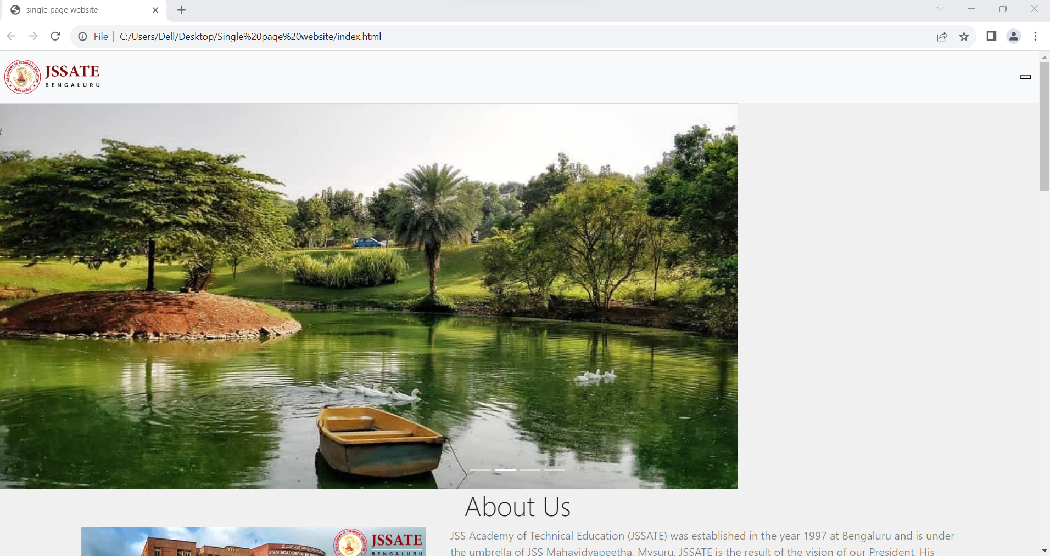

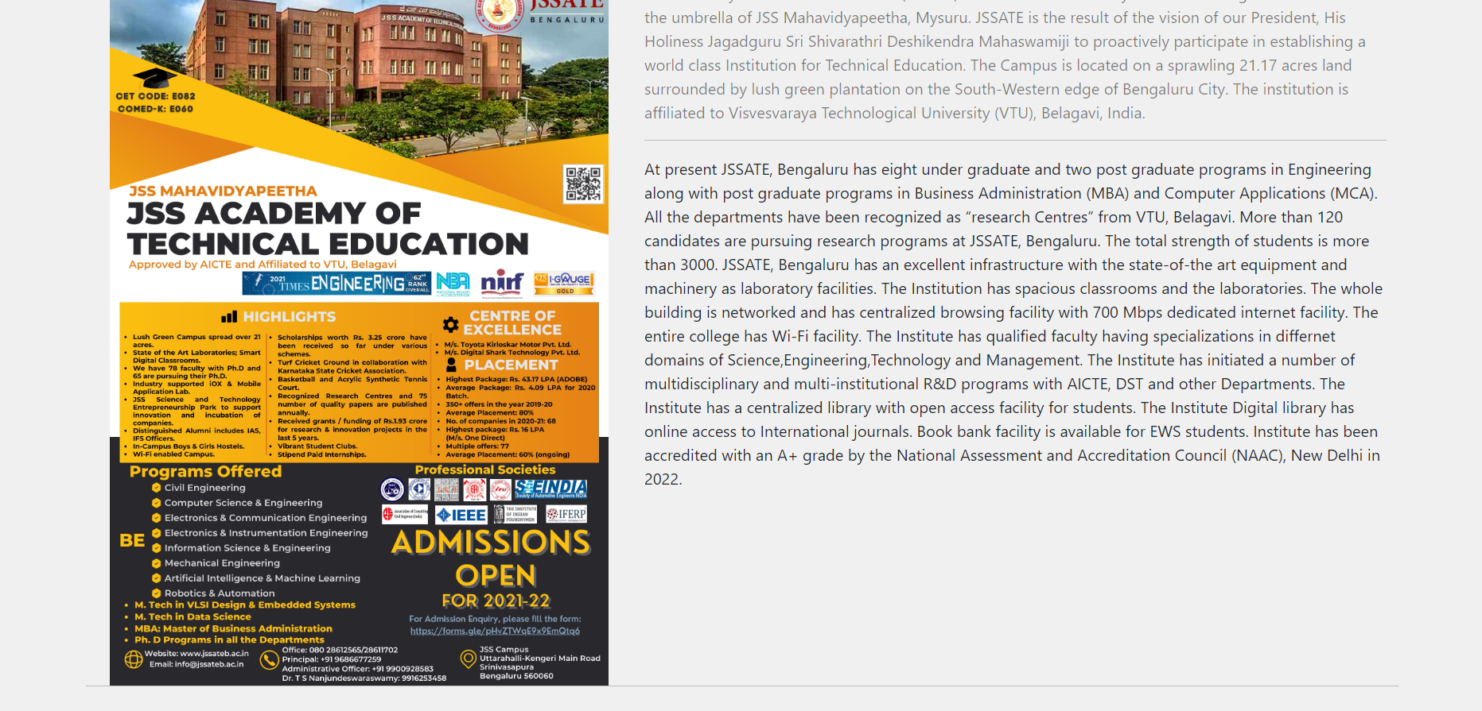

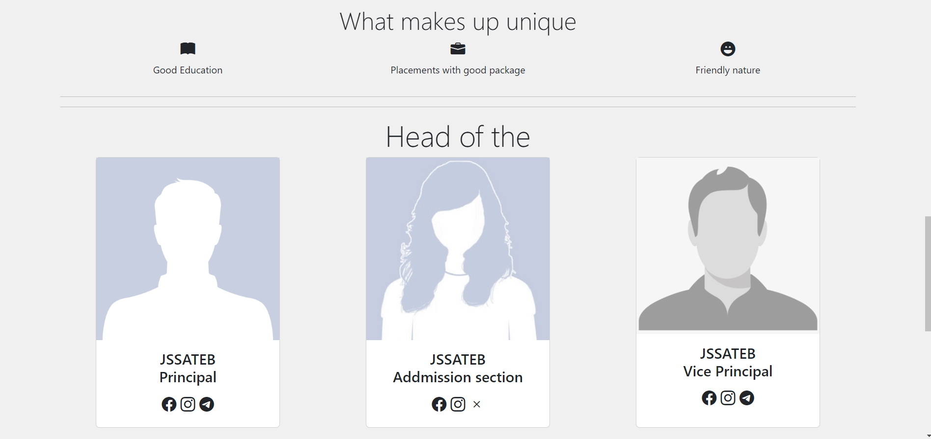

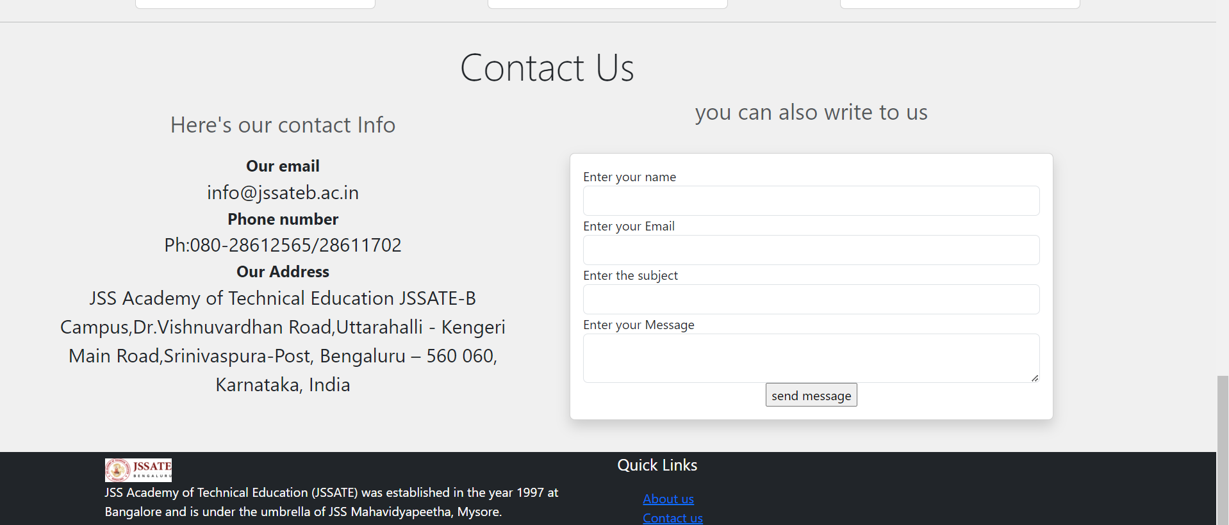

**Output**

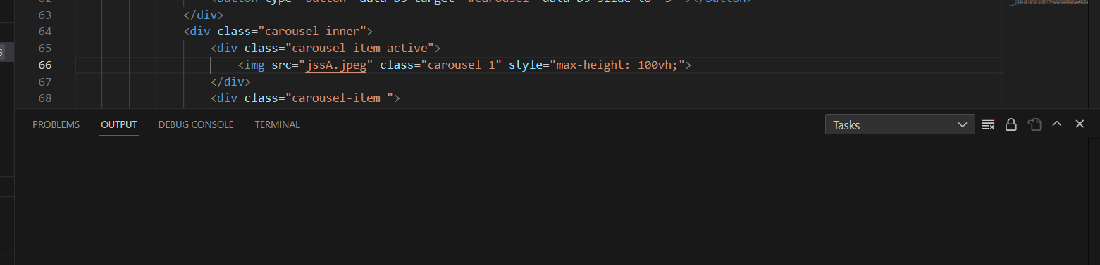

**Conclusion**

The HTML code represents a single-page website for JSS Academy of Technical Education (JSSATE). The website follows a minimalist design approach, presenting all essential information on a single page. Let's summarize the key components and features of the website:

1. Navigation: The website includes a fixed navigation bar at the top, allowing users to access different sections of the page, such as "Home," "About Us," and "Contact Us." The navigation is designed to collapse into a mobile-friendly menu when viewed on smaller screens.

2. Carousel: The website incorporates a carousel at the header, showcasing multiple images related to the institution. The carousel provides a visually appealing slideshow that automatically transitions through the images.

3. About Us Section: The "About Us" section provides detailed information about JSS Academy of Technical Education. It includes a brief introduction to the institution, its history, and the programs it offers. The section also highlights what makes the institution unique, presented with icons and short descriptions.

4. Team Section: The "Head of the Team" section introduces key faculty members, including the Principal and Vice Principal, along with their respective roles. Each member is represented with an image and relevant social media icons for further interaction.

5. Contact Section: The "Contact Us" section includes the institution's contact information, such as email, phone number, and address. It also provides a contact form for users to send messages directly to the institution.

6. Footer: The website's footer includes the JSS Academy of Technical Education logo, along with a brief description of the institution. It also offers quick links to the "About Us" and "Contact Us" sections for easy navigation.

7. Styling: The website utilizes the Bootstrap framework and custom CSS styles to achieve a responsive and visually pleasing design. The color scheme predominantly features light colors with teal accents.

In conclusion, this single-page website effectively presents essential information about JSS Academy of Technical Education in a user-friendly and engaging manner. The website's concise design and seamless navigation provide a pleasant user experience. However, for a complete and functional website, backend programming may be required to process form submissions and handle other dynamic elements. Overall, the provided HTML code lays a solid foundation for building an attractive single-page website for the institution.